Docker
This page will guide you to quickly install and run EMQX using the official Docker image, and use Docker Compose to build a cluster.

Running a single EMQX node via Docker
This section mainly introduces how to install the latest version of EMQX through Docker image. If you want to experience other versions, you can go to the EMQX download page .
- Run the following command to get the Docker image:
docker pull emqx/ emqx:5.4.1
- Run the following command to start the Docker container.
docker run -d --name emqx -p 1883:1883 -p 8083:8083 -p 8084:8084 -p 8883:8883 -p 18083:18083 emqx/ emqx:5.4.1

Docker deployment considerations
- If you need a persistent Docker container, mount the following directory outside the container so that the data will not be lost even if the container is deleted:
- /opt/emqx/data
/opt/emqx/log
- Start the container and mount the directory:
- docker run -d --name emqx \
-p 1883:1883 -p 8083:8083 \
-p 8084:8084 -p 8883:8883 \
-p 18083:18083 \
-v $PWD/data:/opt/emqx/data \
-v $PWD/log:/opt/emqx/log \
emqx/emqx:5.4.1
- localhost or 127.0.0.1 in Docker refers to the internal address of the container. To access the host address, use the host's real IP address or use host networking mode . If you are using Docker for Mac or Docker for Windows, you can use host.docker.internal as the host address.
- Since EMQX uses data/mnesia/<node name> as the data storage directory, please use fixed information such as hostname or FQDN as the node name to avoid data loss due to node name changes.

Building an EMQX cluster with Docker Compose
Docker Compose is a tool for orchestrating and running multiple containers. The following guide will guide you to use Docker Compose to create a simple EMQX static cluster for testing.
Please note that the Docker Compose example file in this section is only suitable for local testing. If you need to deploy a cluster in a production environment, refer to Building a Cluster .
Currently, Docker Compose is included in the Docker installation package and does not need to be installed separately. If your Docker does not include Compose, please refer to Install Docker Compose to install it.
- a docker-compose.yml file in any directory with the following content:
{% emqxce %}
version: '3'
services:
emqx1:
image: emqx:5.4.1
container_name: emqx1
environment:
- "EMQX_NODE_NAME=emqx@node1.emqx.io"
- "EMQX_CLUSTER__DISCOVERY_STRATEGY=static"
- "EMQX_CLUSTER__STATIC__SEEDS=[emqx@node1.emqx.io,emqx@node2.emqx.io]"
healthcheck:
test: ["CMD", "/opt/emqx/bin/emqx ctl", "status"]
interval: 5s
timeout: 25s
retries: 5
networks:
emqx-bridge:
aliases:
- node1.emqx.io
ports:
- 1883:1883
- 8083:8083
- 8084:8084
- 8883:8883
- 18083:18083
# volumes:
# - $PWD/emqx1_data:/opt/emqx/data
emqx2:
image: emqx:5.4.1
container_name: emqx2
environment:
- "EMQX_NODE_NAME=emqx@node2.emqx.io"
- "EMQX_CLUSTER__DISCOVERY_STRATEGY=static"
- "EMQX_CLUSTER__STATIC__SEEDS=[emqx@node1.emqx.io,emqx@node2.emqx.io]"
healthcheck:
test: ["CMD", "/opt/emqx/bin/emqx ctl", "status"]
interval: 5s
timeout: 25s
retries: 5
networks:
emqx-bridge:
aliases:
- node2.emqx.io
# volumes:
# - $PWD/emqx2_data:/opt/emqx/data
networks:
emqx-bridge:
driver: bridge
{% endemqxce %}
{% emqxee %}
version: '3'
services:
emqx1:
image: emqx/emqx-enterprise:@EE_VERSION@
container_name: emqx1
environment:
- "EMQX_NODE_NAME=emqx@node1.emqx.com"
- "EMQX_CLUSTER__DISCOVERY_STRATEGY=static"
- "EMQX_CLUSTER__STATIC__SEEDS=[emqx@node1.emqx.com,emqx@node2.emqx.com]"
healthcheck:
test: ["CMD", "/opt/emqx/bin/emqx ctl", "status"]
interval: 5s
timeout: 25s
retries: 5
networks:
emqx-bridge:
aliases:
- node1.emqx.com
ports:
- 1883:1883
- 8083:8083
- 8084:8084
- 8883:8883
- 18083:18083
# volumes:
# - $PWD/emqx1_data:/opt/emqx/data
emqx2:
image: emqx/emqx-enterprise:@EE_VERSION@
container_name: emqx2
environment:
- "EMQX_NODE_NAME=emqx@node2.emqx.com"
- "EMQX_CLUSTER__DISCOVERY_STRATEGY=static"
- "EMQX_CLUSTER__STATIC__SEEDS=[emqx@node1.emqx.com,emqx@node2.emqx.com]"
healthcheck:
test: ["CMD", "/opt/emqx/bin/emqx ctl", "status"]
interval: 5s
timeout: 25s
retries: 5
networks:
emqx-bridge:
aliases:
- node2.emqx.com
# volumes:
# - $PWD/emqx2_data:/opt/emqx/data
networks:
emqx-bridge:
driver: bridge
- the docker-compose.yml file is located through the command line , and then enter the following command to start the EMQX cluster:
docker-compose up -d
- Check the cluster status
$ docker exec -it emqx1 sh -c "emqx ctl cluster status"
Cluster status: #{running_nodes => ['emqx@node1.emqx.com','emqx@node2.emqx.com'],
stopped_nodes = > []}

CentOS/RHEL
This page will guide you on how to download, install and start EMQX on CentOS/RHEL systems.
Supported CentOS/RHEL versions:
- Amazon Linux 2023
- Amazon Linux 2
- Rocky Linux 9 (RHEL 9)
- Rocky Linux 8 (RHEL 8)
- CentOS 7 (RHEL 7)

Install via rpm
EMQX also supports installation via rpm packages. This section uses CentOS 8 as an example to demonstrate how to download the latest version of EMQX. If you wish to install on other supported systems or try out other versions, please visit the EMQX download page for detailed installation information.
Please select the corresponding installation method according to the CPU architecture.
amd64
- Download emqx-5.4.1-el8-amd64.rpm .
- wget https://www.emqx.com/zh/downloads/broker/5.4.1/emqx-5.4.1-el8-amd64.rpm
- Install EMQX.
- sudo yum install emqx-5.4.1-el8-amd64.rpm -y
arm64
1. Download emqx-5.4.1-el8-amd64.rpm .
wget https://www.emqx.com/zh/downloads/broker/5.4.1/emqx-5.4.1-el8-arm64.rpm
- Install EMQX.
- sudo yum install emqx-5.4.1-el8-arm64.rpm -y

Start EMQX
You can start EMQX in the following 3 ways.
- Direct boot:
- emqx start
- emqx ctl status
- Start systemctl:
- sudo systemctl start emqx
- Service startup:
- sudo service emqx start

Uninstall EMQX
After the service is completed, you can uninstall EMQX using the following command:
sudo yum remove emqx

Install via tar.gz
EMQX also supports installation via tar.gz packages. This section uses CentOS 8 as an example to demonstrate how to download the latest version of EMQX. If you wish to install on other supported systems or try out other versions, please visit the EMQX download page for detailed installation information.
Please select the corresponding installation method according to the CPU architecture.
amd64
- Download emqx-5.4.1-el8-arm64.tar.gz
- wget https://www.emqx.com/zh/downloads/broker/5.4.1/emqx-5.4.1-el8-amd64.tar.gz
- Install EMQX.
- mkdir -p emqx && tar -zxvf emqx-5.4.1-el8-amd64.tar.gz -C emqx
arm64
1. Download emqx-5.4.1-el8-arm64.tar.gz.
wget https://www.emqx.com/zh/downloads/broker/5.4.1/emqx-5.4.1-el8-arm64.tar.gz
- Install EMQX.
- \ mkdir -p emqx && tar -zxvf emqx-5.4.1-el8-arm64.tar.gz -C emqx

Start EMQX
After the installation is complete, you can start EMQX using the following command.
./emqx/bin/emqx start

Ubuntu
This page will guide you on how to download, install and start EMQX in Ubuntu.
Supported Ubuntu versions:
Ubuntu 22.04
Ubuntu 20.04
Ubuntu 18.04

Install via deb
Please select the corresponding installation method according to the CPU architecture.
amd64
1. Download emqx-5.4.1-ubuntu22.04-amd64.deb.
wget https://www.emqx.com/zh/downloads/broker/5.4.1/emqx-5.4.1-ubuntu22.04-amd64.deb

- Install EMQX.
sudo apt install ./emqx-5.4.1-ubuntu22.04-amd64.deb

arm64
1. Download emqx-5.4.1-ubuntu22.04-arm64.deb.
wget https://www.emqx.com/zh/downloads/broker/5.4.1/emqx-5.4.1-ubuntu22.04-arm64.deb
2. Install EMQX.
sudo apt install ./emqx-5.4.1-ubuntu22.04-arm64.deb

Start EMQX
You can start EMQX in the following three ways.
Direct boot:
emqx start
emqx ctl status
Start systemctl:
sudo systemctl start emqx

Service startup:
sudo service emqx start

Uninstall EMQX
After the service is completed, you can uninstall EMQX using the following command:
sudo apt remove --purge emqx

EMQX configuration:
http:// Doman or ip :18083
Default account: admin Default password: publish
- Create a key in System Settings-API Key for API calls
- In Management - MQTT Advanced Features - Broker Subscription, add:
/powerbank/${clientid}/user/get
/powerbank/${clientid}/user/heart

- Create two rules in Integration-Rules
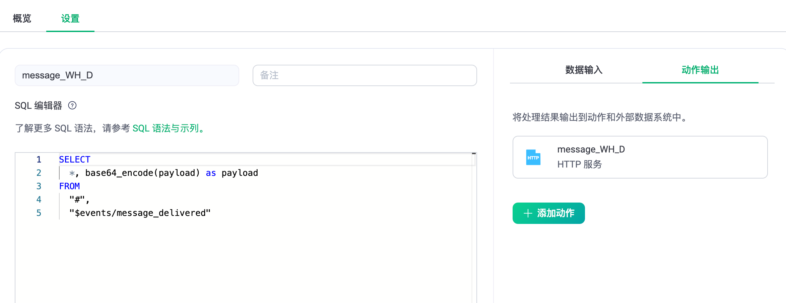
SELECT
* , base64_encode(payload) as payload
FROM
"#",
"$events/message_delivered"
Used to monitor information sent by the device
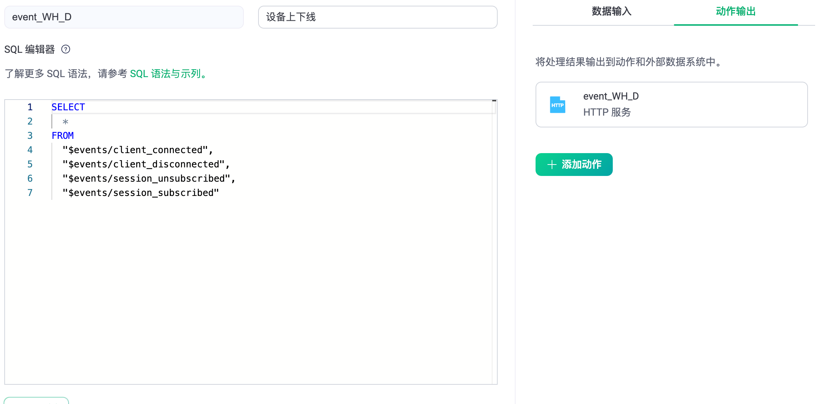
SELECT
*
FROM
"$events/client_connected",
"$events/client_disconnected",
"$events/session_unsubscribed",
"$events/session_subscribed"
Used to monitor device online and offline messages:
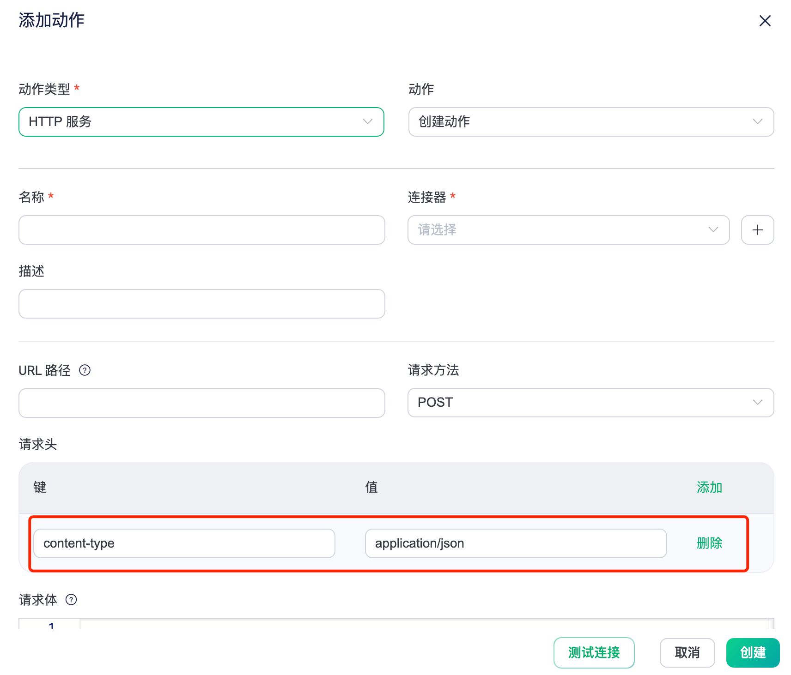
Create an action for the http service under each rule. The monitored events will be sent to your server via http request. You need to delete the red part. The http service can also be set up through webhook: the request header part is not required
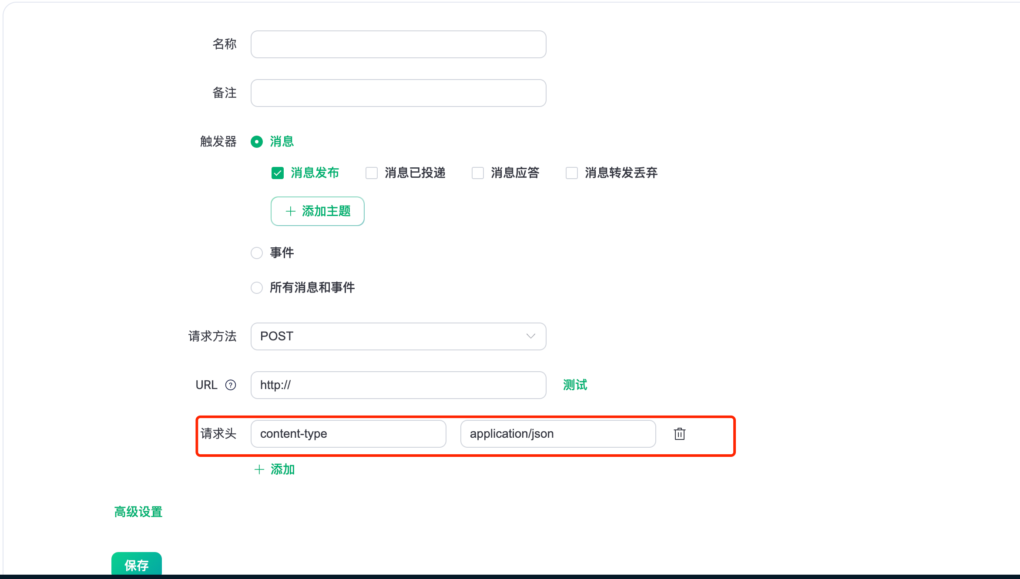
In Management-Cluster Configuration-Listener, only port 1883 needs to be reserved.
In Access Control - Client Authentication, set up built-in database authentication:
